Course: ENCS304 – Computer Networks
Name: Nishant Kumar
Roll Number: 2301730068
Program: B.Tech CSE (AI & ML)

Task 4: Failure Test
Procedure:
• Disconnected one link in ring topology
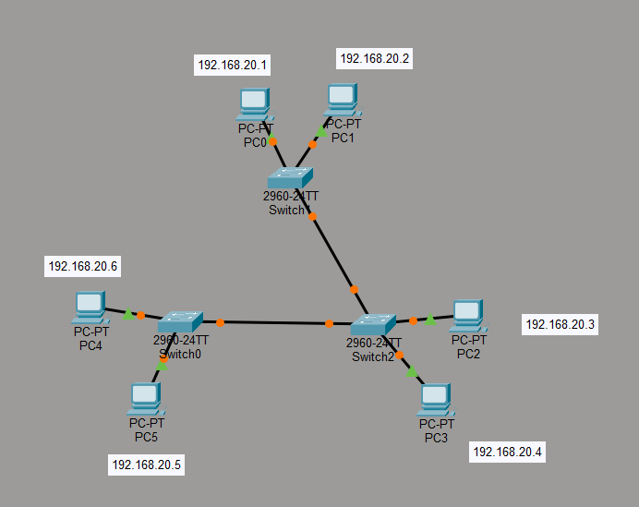
Result:
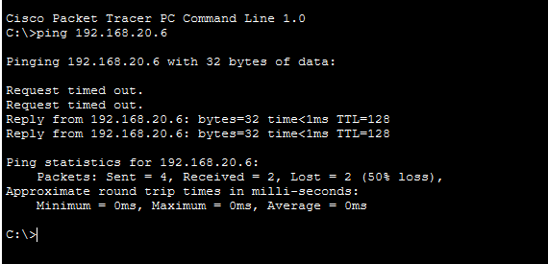

• Communication continued using alternate path
Observations:
• Ring topology provides redundancy
• Better fault tolerance than simple star (if central device fails)

